Cox Regression

Objective:

What factors impact the survival probability of a patient with primary brain tumor? Do patients’ sex, tumor location, gross tumor volume, tumor type, patient healthiness index (Karnofsky index), and tumor treatment method have a significant relationship with survival probability?

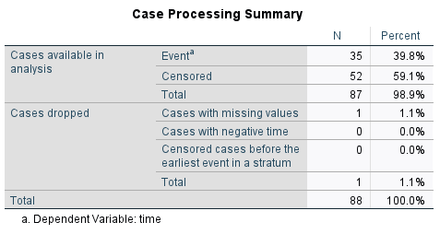

The Case Processing Summary table shows the number of cases processed in the analysis and the number of cases excluded or dropped. The Cases dropped row indicates that 1 case was dropped because we marked it as a missing value. There are 35 cases (39.8%) that experienced the Event (death) and 52 cases (59.1%) that were Censored (survived or were not tracked for non-informative reasons).

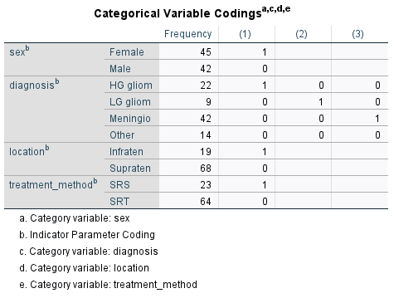

Block 0: Beginning Block



Block 0 shows the -2 Log Likelihood statistic when there are no predictors in the model (the null model). We can use this information criterion to compare with the model which has all predictors entered in Block 1. In this way, the effect of adding predictors to the model can be calculated and interpreted.

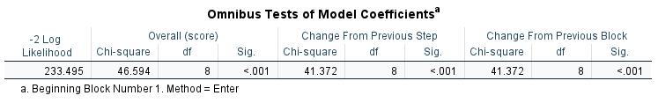

We can see that in Block 0, the statistic is 274.867 and in Block 1 it decreases to 233.495 (the smaller, the better). This decrease is noted in the middle of the table (Change From Previous Step), which is 41.372, and statistically significant. It means that the simultaneous addition of all predictors to the model in Block 0 (null model, then becoming Block 1) has significantly improved model performance (it’s a better model than the null model). So, we conclude that our model is overall significant. But we need to know which predictors have significantly contributed to the model.

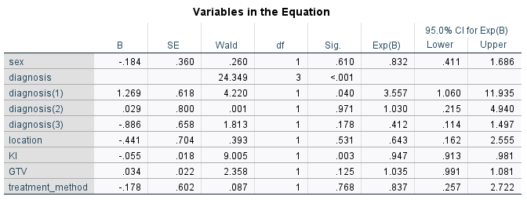

The effect of each variable is denoted by the B coefficients (on log-odds scale) and if the effect is significant it is indicated in the Sig. column. The column Exp(B) transforms the coefficients from the log-odd scale to odds scale and is commonly known as the hazard ratio.

According to the coefficients table, the effect of sex is not statistically significant (p = 0.610). Next, the overall effect of the Diagnosis factor is significant (p < 0.05, note that there is no coefficient for the Diagnosis factor, but there are coefficients for each category of the Diagnosis factor. The effect of tumor Location is not statistically significant (p = 0.531). The effect of KI is statistically significant (p = 0.003). The effect of GTV is not statistically significant (p = 0.125). Also, the effect of Treatment method is not statistically significant (p = 0.768).

Now, let’s interpret the results for statistically significant predictors in the Cox regression. If the B coefficients are negative or if the Exp(B) values are less than 1, the predictor has a decreasing effect on hazard ratio. For the continuous predictor KI, for each unit increase in KI, the hazard ratio (death) decreases by (1-0.947) x 100 = 5.3%, holding all other predictors constant.

Interpretation:
The Cox proportional hazards regression was performed to assess the impact of patients’ sex, brain tumor diagnosis, tumor location, Karnofsky Index (KI), gross tumor volume (GTV), and treatment method on survival probability in patients with primary brain tumors. The proportional hazards assumption was verified and met for all covariates. Diagnosis type was modeled with “Other” as the reference category. The effects of sex, tumor location, GTV, and treatment method were not statistically significant (p > 0.05). KI was statistically significant (χ² = 9.005, p < 0.05), with a coefficient of -0.055 and a hazard ratio of 0.947 (95% CI: 0.913-0.981), indicating that higher KI scores were associated with improved survival. Diagnosis type was also statistically significant (χ²=24.349, p < 0.05); patients with HG glioma had a significantly higher hazard ratio (3.557, 95% CI: 1.060-11.936) compared to the “Other” group. Differences between LG glioma and “Other” and between meningioma and “Other” were not statistically significant (p > 0.05).

